**Prerequisites:**

1. On mac we should have it by default.On windows - Install for Apache AB [here](https://cedric-dumont.com/2017/02/01/install-apache-benchmarking-tool-ab-on-windows/)

**Check:** Type **ab** in terminal

1. Download Gatling from [here](https://gatling.io/download/).
   1. Gatling 2.3

Check: It is a folder. cd to bin inside the folder and run **./recorder.sh**

1. Install Java 8
   1. java version "1.8.0_151"

Check:Type **java -version in terminal**

1. Install Scala (We can do brew install scala)
   1. scala: stable 2.12.4

Check: Type **scala -version**

1. Install Gradle (We can brew install gradle)
   1. gradle: stable 4.4.1

Check: Type **gradle -v**

1. Git clone git@github.com:nalinikanth/gatling_demo_base.git

**Apache Benchmarking(AB)**

A command line tool used to do benchmarking.  
<https://httpd.apache.org/docs/2.4/programs/ab.html>

**ab** [ -**A** auth-username:password ] [ -**b** windowsize ] [ -**B** local-address ] [ -**c** concurrency ] [ -**C** cookie-name=value ] [ -**d** ] [ -**e** csv-file] [ -**f** protocol ] [ -**g** gnuplot-file ] [ -**h** ] [ -**H** custom-header ] [ -**i** ] [ -**k** ] [ -**l** ] [ -**m** HTTP-method ] [ -**n** requests ] [ -**p** POST-file] [ -**P** proxy-auth-username:password ] [ -**q** ] [ -**r** ] [ -**s** timeout ] [ -**S** ] [ -**t** timelimit ] [ -**T** content-type ] [ -**u** PUT-file ] [ -**v** verbosity] [ -**V** ] [ -**w** ] [ -**x** <table>-attributes ] [ -**X** proxy[:port] ] [ -**y** <tr>-attributes ] [ -**z** <td>-attributes ] [ -**Z** ciphersuite ] [http[s]://]hostname[:port]/path

First test:

**ab -n 10 -c 2** [**https://www.google.com/**](https://www.google.com/) **-n no of hits  
-c no of hits concurrently  
  
ab -n 10 -c 2 -e abc.csv** [**https://www.google.com/**](https://www.google.com/) **ab -n 10 -c 2 -g abc.txt** [**https://www.google.com/**](https://www.google.com/) **ab -n 10 -c 2 -p <post-file loc>** [**https://www.google.com/**](https://www.google.com/)

**GATLING**

**Gatling intro and installation:  
Installation:**

In order to run Gatling, you need to have a JDK installed. Gatling requires **JDK8**, yet we recommend that you use an up-to-date version.

1. Download Gatling: <http://gatling.io/download/>
2. Copy the folder in home location or a location where you want it to run from. Windows users any folder other than programs.
3. Unzip the folder.
   1. Using the recorder:
      1. On linux or unix : $GATLING_HOME/bin/recorder.sh
      2. On windows : $GATLING_HOME/bin/recorder.bat

**License:** [Apache License 2.0](https://github.com/gatling/gatling/blob/master/LICENSE.txt)  
  
**Hands on with Gatling:**-Open terminal and launch Gating recorder  
**Mac:**   
Gatling Path: /Users/<user name>/gatling-charts-highcharts-bundle-2.3.0/bin  
Type: $ cd /Users/<user name>/gatling-charts-highcharts-bundle-2.3.0/bin  
$ **./recorder.sh**  
**Windows:**Gatling Path: c:/Users/<user name>/gatling-charts-highcharts-bundle-2.3.0/bin  
cd c:/Users/<user name>/gatling-charts-highcharts-bundle-2.3.0/bin  
On cmd : **recorder.bat**

Gatling should get launched:  
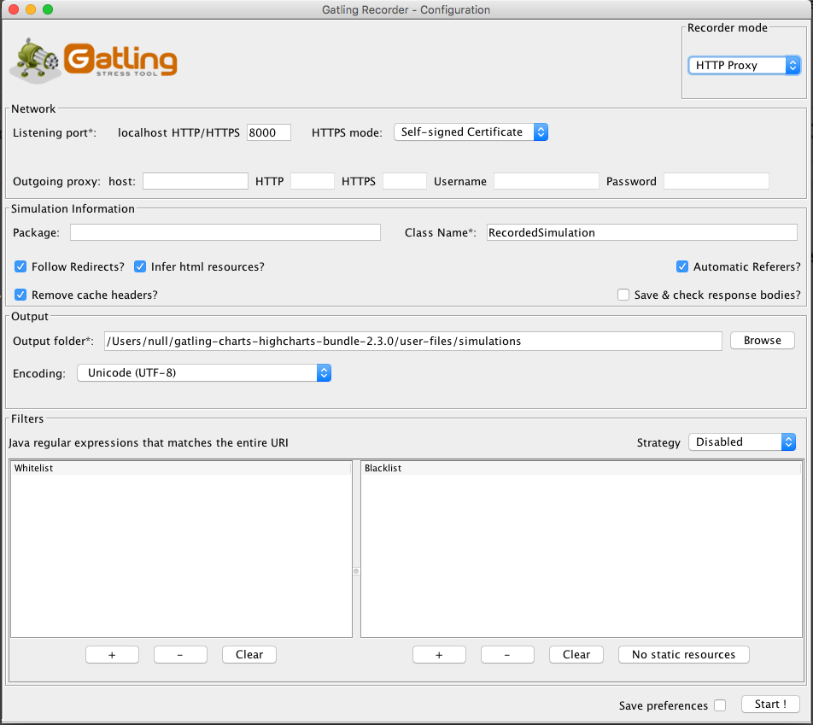

**Recorder in gatling, proxy settings:***Look at the recorder mode and make sure it is HTTP proxy.  
Network: Listening port is 8000  
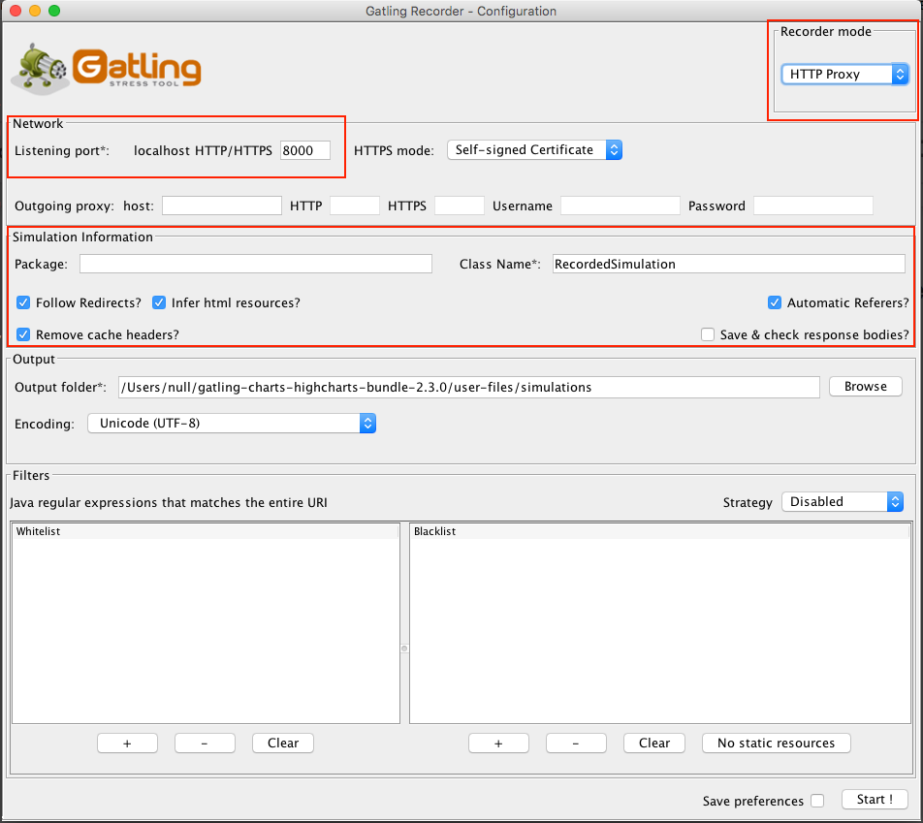*  
 *Basic Simulation* name  
 *Follow Redirects?* Checked  
 *Automatic Referrers?* Checked

*Set the firefox proxy so that Gatling can intercept your firefox browser,:*Set proxy on the browser to listen to gatlings proxy  
 Browser settings -> Advanced -> Network -> settings -> Manual proxy -> set gatling proxy and check use this proxy for all protocols   
<http://gatling.io/docs/current/http/recorder/#recorder>

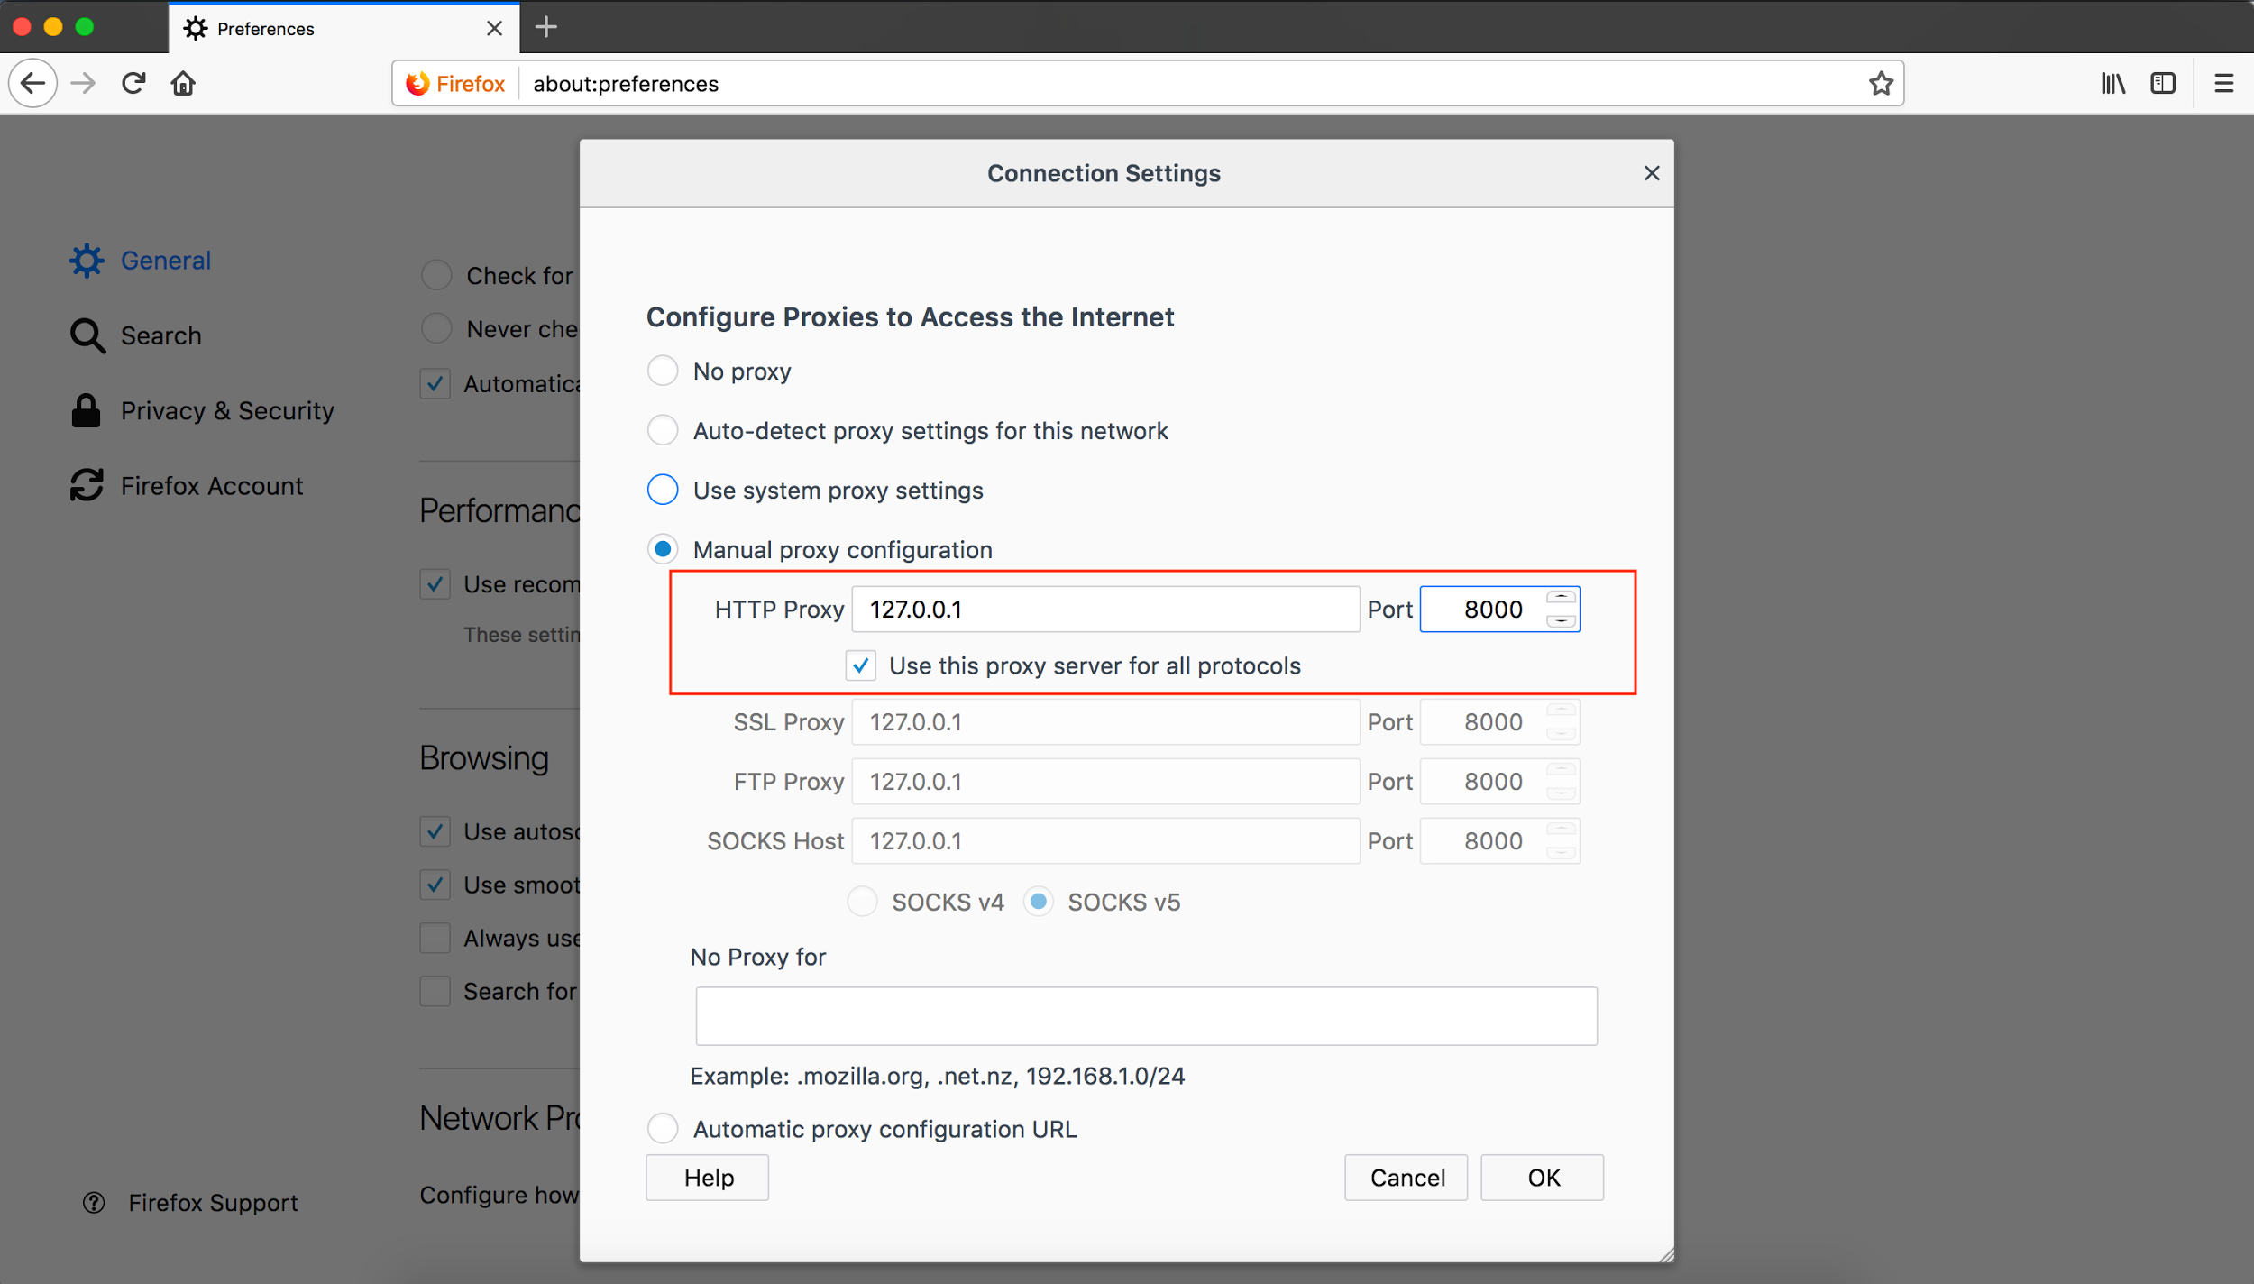

**First script:  
Go to Gatling and click on start.**  
Open firefox and visit [**http://blazedemo.com**](http://blazedemo.com) **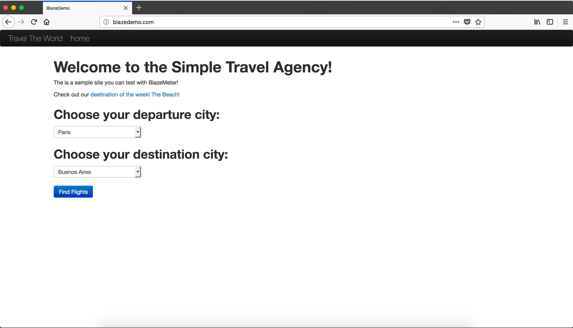  
  
Recorder should look like:  
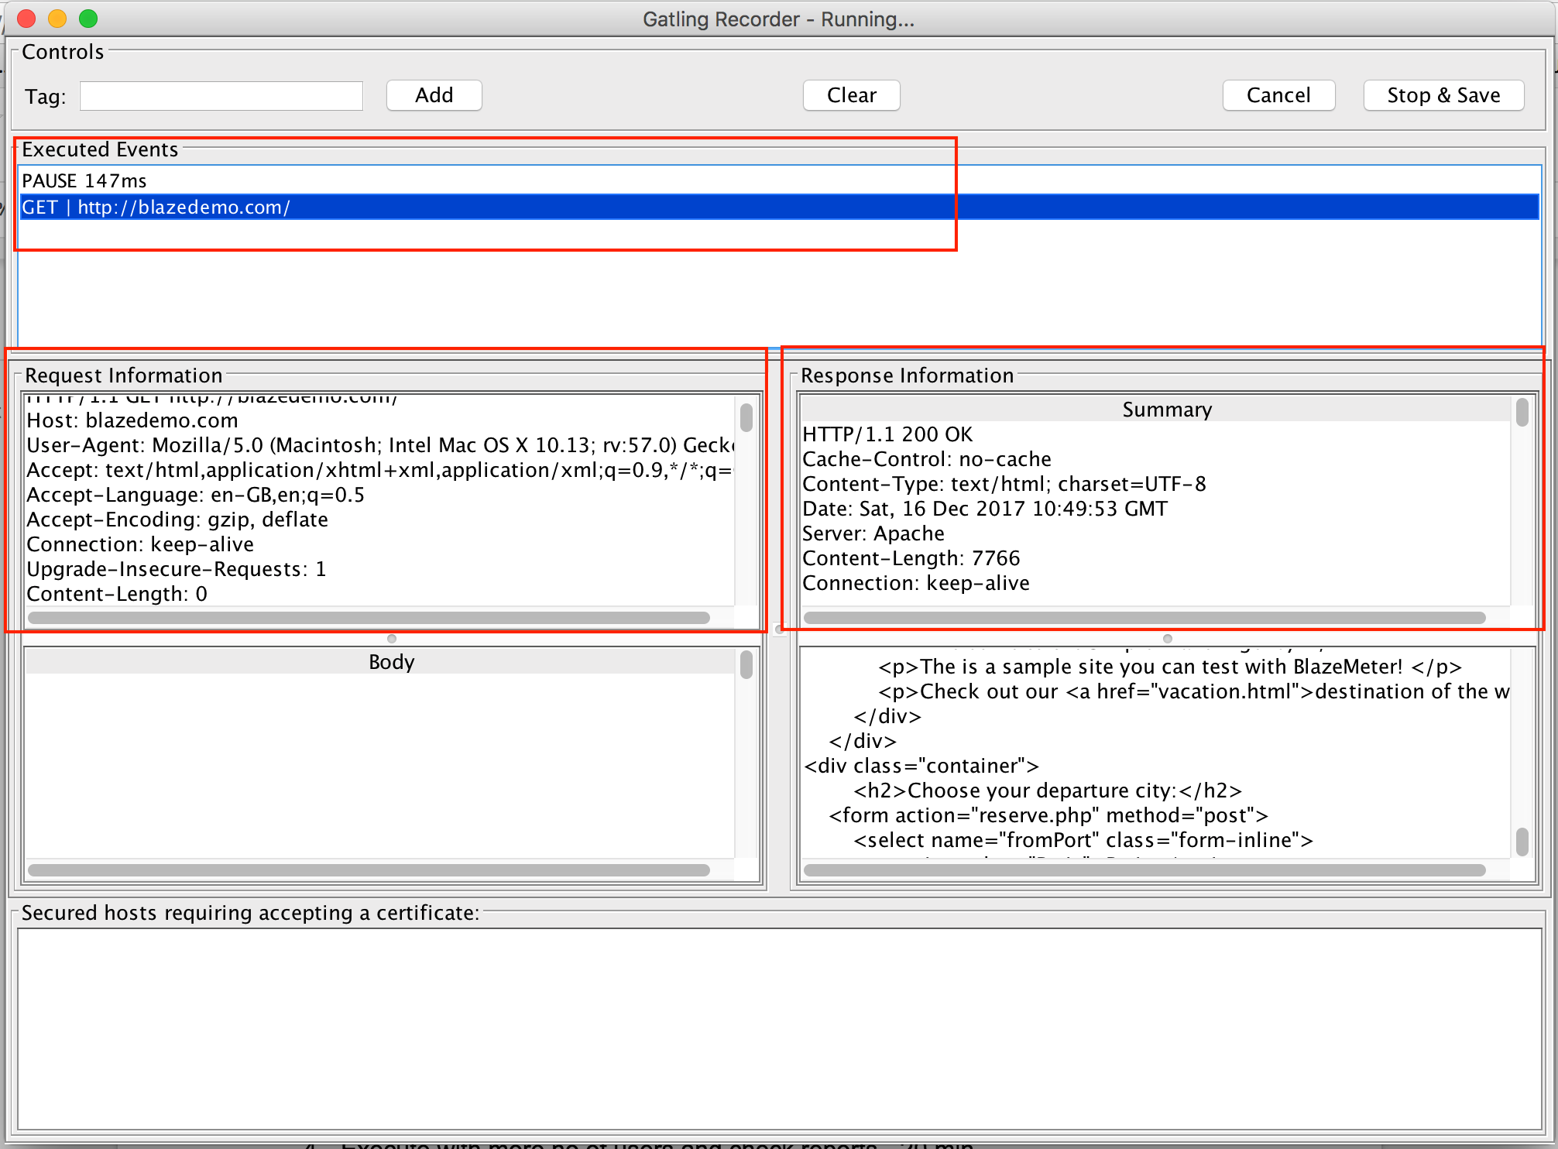  
  
On firefox on blaze demo site:** Select departure and destination city  
 Click on find Flights  
 Choose any flight  
 Give details and click on book.  
On Gatling recorder click on stop and save.  
  
**Your recorder will look like:  
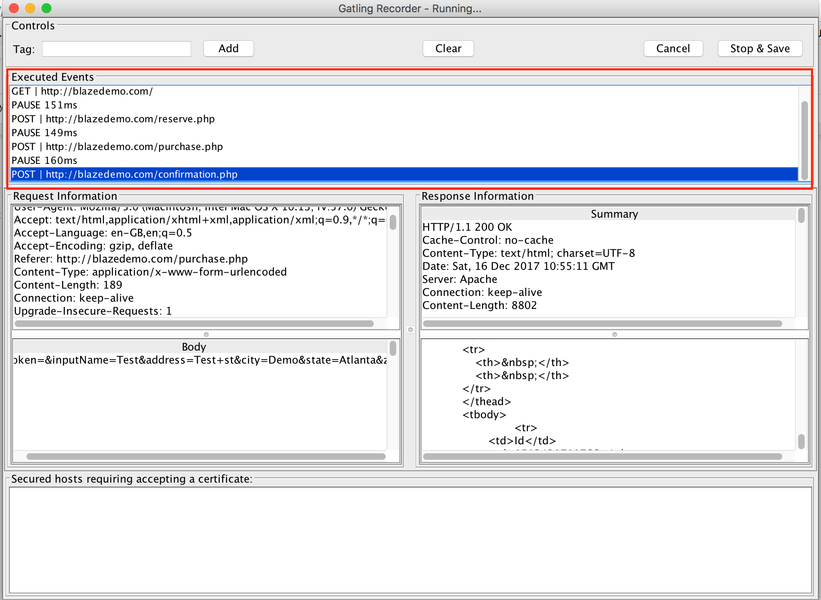  
  
Goto location:  
$ <Gatling_Home>/user-files/simulations/blazedemo**You should see the folder blazedemo and a file DemoSimulation.scala  
  
**Running first script:  
Mac:**   
Gatling Path: /Users/<user name>/gatling-charts-highcharts-bundle-2.3.0/bin  
Type: $ cd /Users/<user name>/gatling-charts-highcharts-bundle-2.3.0/bin  
$ ./gatling.sh  
**Windows:**Gatling Path: c:/Users/<user name>/gatling-charts-highcharts-bundle-2.3.0/bin  
cd c:/Users/<user name>/gatling-charts-highcharts-bundle-2.3.0/bin  
 gatling.bat  
 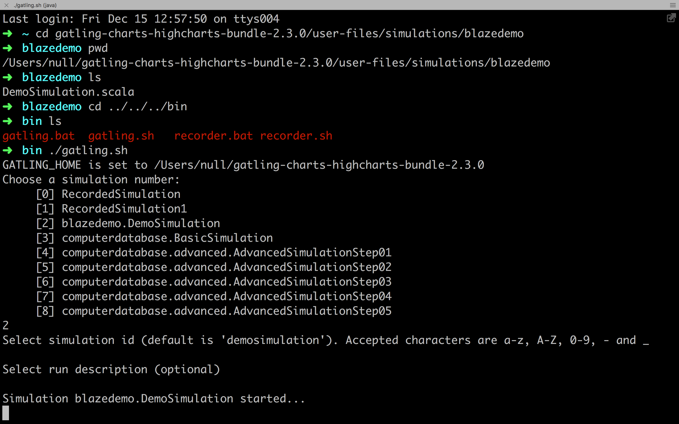Select 2 which is blazedemo.Demosimulation  
  
Go to results folder in Gating_Home  
Open the simulation that starts with simulation id that you have given.  
Open index.html file  
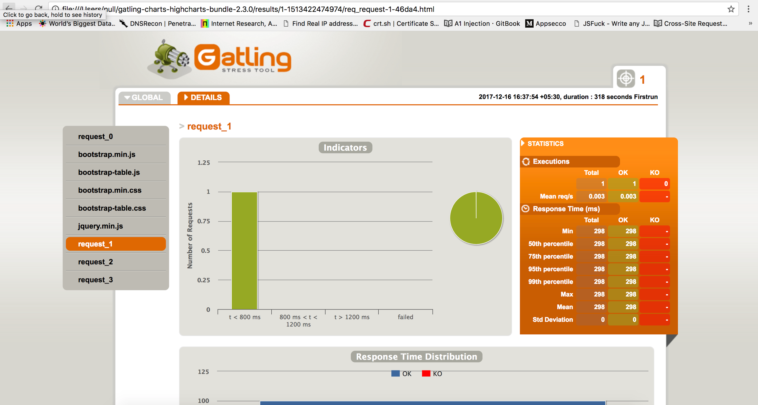  
  
 **whitelisting and blacklisting:**Goto gatling add .*\.php in white listing window.  
Click on no static resources on blacklisting window.  
Start the proxy and record the script again.

Editing scripts and adding checks & assertions - 20 min  
  
**Parameters, user load modelling and think time:  
Slide--**  
**Execute with more no of users and check reports:  
$ <Gatling_Home>/user-files/simulations/blazedemo**You should see the folder blazedemo and a file DemoSimulation.scala  
Now open Demosimulation.scala in Gating_Home/simulations.  
Change inject(atOnceUsers(1)) - inject(atOnceUsers(3))  
Save the script.  
  
Run ./gatling.sh or gatling.bat in **$<Gatling_Home>/bin**Select the simulation blazedemo.DemoSimulation and open the execution report (index.html) from the latest simulation result folder.

## Setting Up a project with Gatling

**Running scripts with gradle:**

1. Clone the base project from
2. Open project IntelliJ Idea CE
3. Create below folder structure

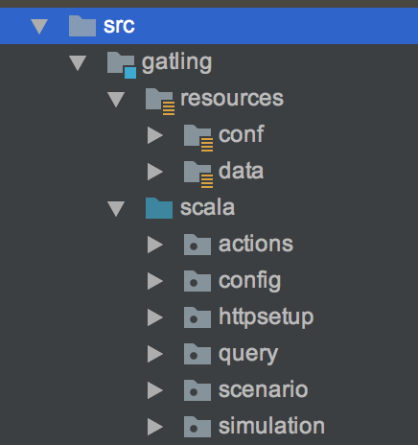

2. Copy the simulation <TestSimulation.simulation> from $Gatling_home/User-files to simulations folder.

# **Steps to run the simulation**

1. Run the simulation in CLI using following command

osx/ Linux - ./gradlew gatlingRun

windows - ./gradlew.bat gatlingRun

to run a single simulation ./gradlew gatlingRun-<packagename.simulationname>

eg: ./gradlew gatlingRun-simulation.LoginSimulation

It runs the simulation(s) present in *src/gatling/scala/simulation*. The simulation result is available in *build/reports/gatling/{simulation-number}/index.html*